
https://jmc2026.sciencesconf.org/
XXX0i : Write here the code-number and name of the mini-symposia

Title of the abstract
Author ¹, Author²
1 - Labo 1
2 – Labo 2

Guidelines abstract:
Please select only one mini-symposia for each abstract
Add here the description and images you want for your abstract.
If possible please try to stay within 1 page (300 words).

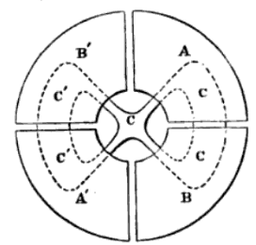
Figure 1 . Caption of Figure if needed

